**Day_13_Assignment**

**Creating EC2 instance using Ansible:**

**Yaml file:**

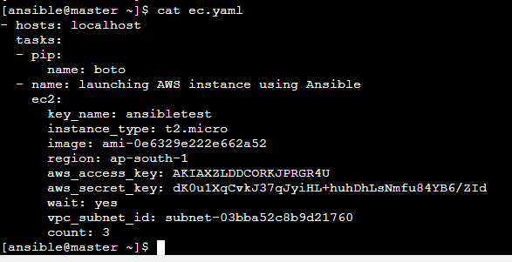

**Three instances are created**

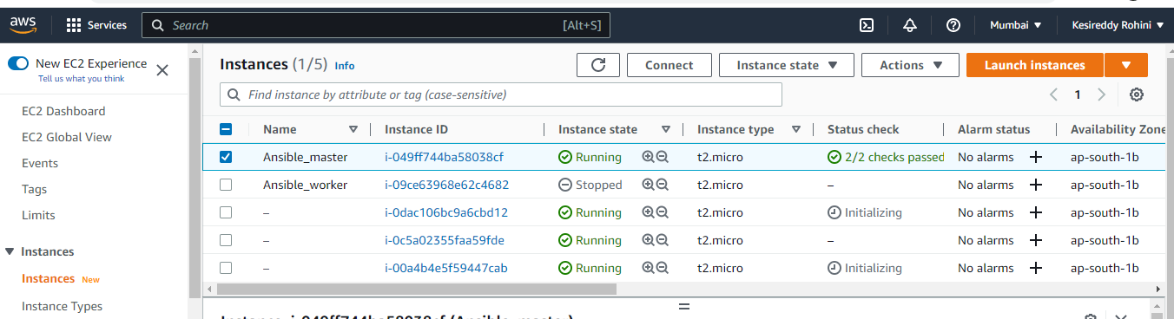

**Execution:**

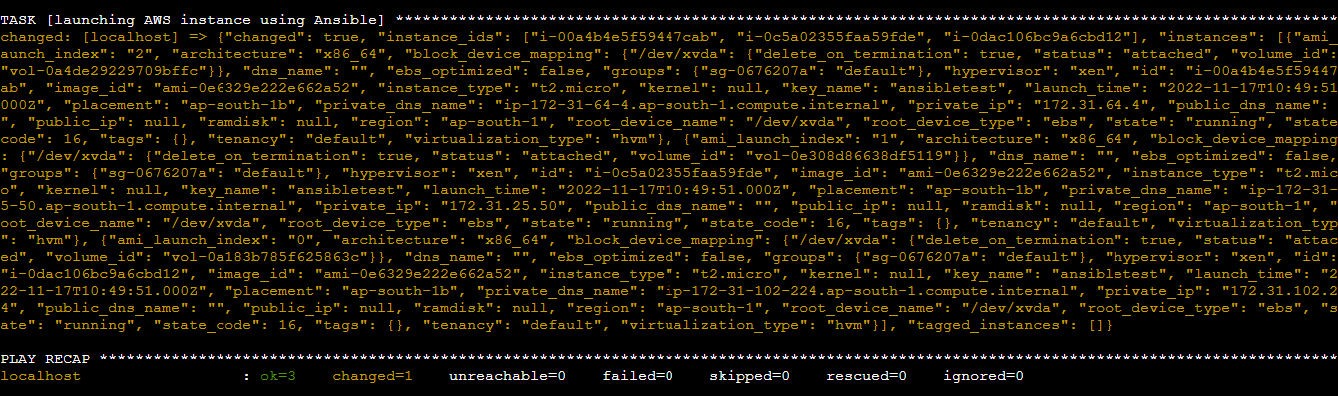

**Creating volume using ansible:**

**Yaml file:**

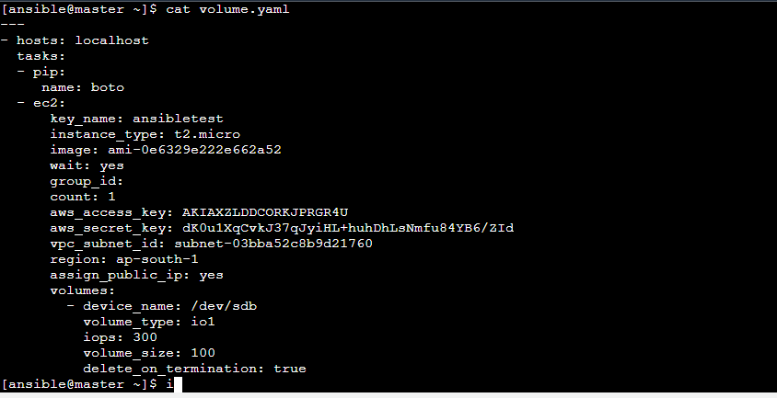

**Volume with type:io1 is created**

